How to Set up Your Bank Account

**(you must do this in order to process a travel expense request)

Navigate to the my.rutgers.edu page and log in (upper right corner)
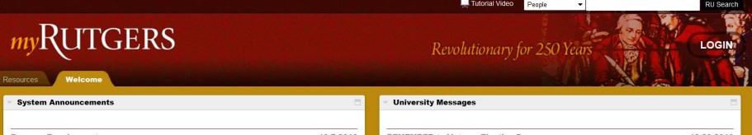

Click the Cornerstone tab and then the Expense Management tile
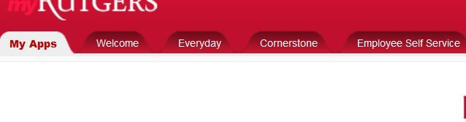

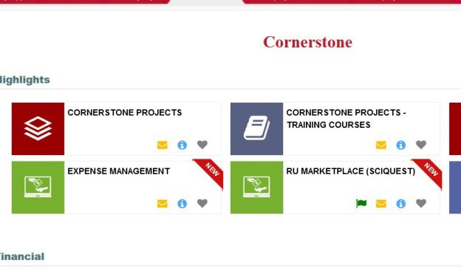

Click tile in the upper right corner:

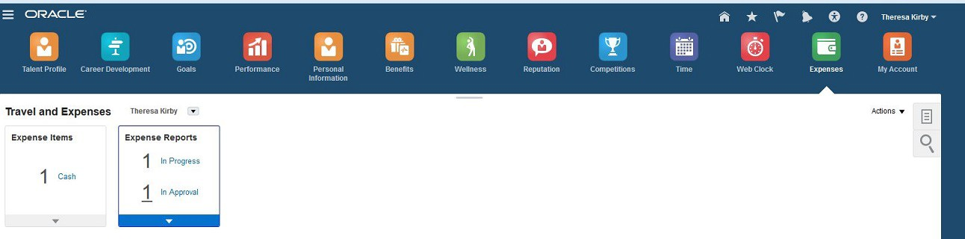

And choose Manage Bank Accounts:

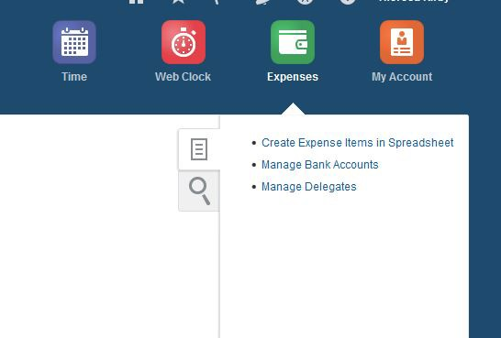

Click the plus sign to add a bank account:

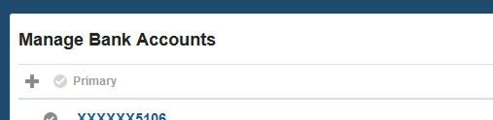

Add bank information and then hit “Save and Close”:

