**Request Cash Advances**

You can also use the Financial Management System to request cash advances for work-related expenses that you are going to incur. **Delegates cannot request a cash advance on behalf of someone else**. Employees: To request a cash advance:

* Navigate to the Travel and Expenses portal
* Click the “Request Cash Advance” link from the Actions menu

* Enter the required fields and click the **Submit** button to submit the Cash Advance for approval

|  |
| --- |
|  |
|  |
|  |

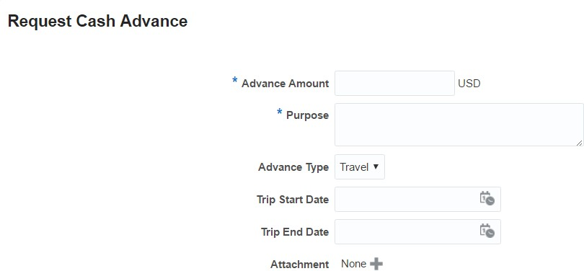

**Delegate**

To assign a delegate, the employee will have to choose . Choose Manage Delegates.

Once in Delegates and Permissions, click on the +.

Click on the magnifying glass next to Person.  Search and Select: Person will come up.

Click on Advanced button.

Under email, type the beginning of the delegate’s email address and click Search.  The person’s name should come up below.  Highlight the line with the email address by clicking on it and click OK.

