TABER: Expense Management - Adding a Delegate
Instructions
Login at my.rutgers.edu and go to the Apps tab. Select the Expense Management app:
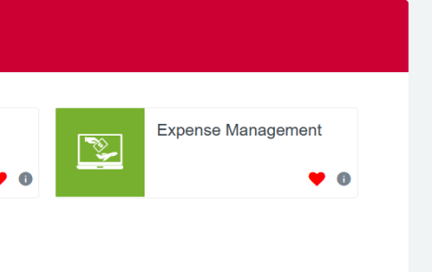

Select the go to task icon (see the round cog)
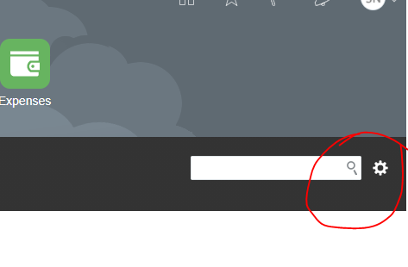

On the next screen select the plus (+) sign to add a delegate
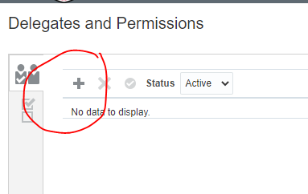

Do a search for me (Shaneika Nelson) by typing my name. Type my name and then click the magnifying glass to view the advanced button. See examples below:
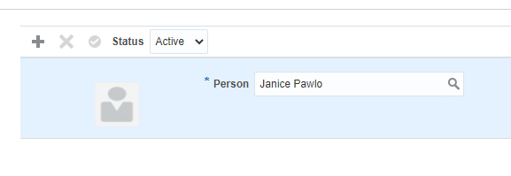

Under email field, type the beginning of my email address (s.nelson@) and click the Search button. My name will come up below. Highlight the line with the email address and click OK (see the examples below).
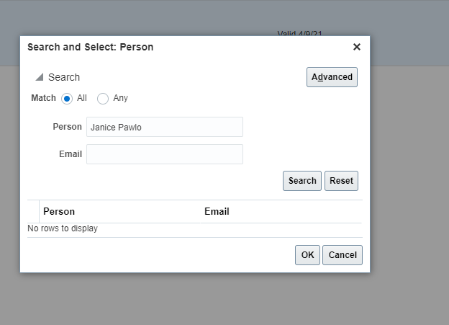

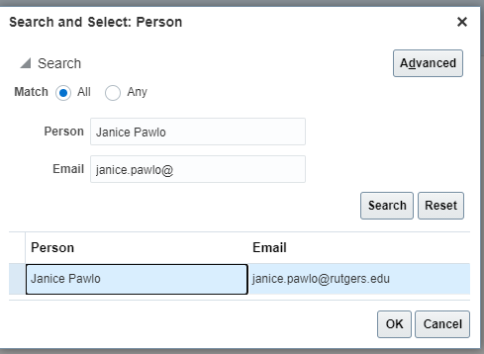

Click Save in the upper right of the screen. Then I will be added as your delegate.
